**Horizon Legal Advice Clinic for Personal Independence Payment Queries**

**Who we are**

We are a pro bono clinic, which is registered as a charity in England and Wales (Charity number: 1165006), that provides free legal advice.

We are primarily a group of law students and graduates who are at various different stages of our career, who work with trainee and qualified solicitors. The clinic is overseen and supervised by Arvin Narendra, who has a wealth of experience in dealing with PIP claims and is based at Duncan Lewis.

We are passionate about helping the communities around us through pro bono initiatives. Many of us have been or are involved with other initiatives such as the Free Representation Unit and clinics set up at the law schools we have attended.

**What we do**

Our focus is on Personal Independence Payments, which is the new system that is replacing Disability Living Allowance.

We are here to help at every stage of the claim and have broken it down into 4 stages:

1. General enquiries and eligibility
2. Filling in the form and making the initial claim
3. Requesting mandatory reconsideration if you are not happy with the initial decision from the Department of Work & Pensions.
4. Appealing the decision if you are still not happy with the decision and attending a tribunal.

**The Clinic**

The clinic is normally run every Tuesday from 6pm to 8:30pm at **Mansfield House, 30 Avenons Road, Plaistow, E13 8HT.** (Please see other side for map and directions).

**Our pledge**

Once we have received your referral we aim to respond and contact you within 2 working days so that we can make an appointment for you to come and see us during a clinic. We aim to be book this appointment in either the next or the following clinic. Once we have met and discussed your query we aim to send you an initial advice letter within 2 weeks.

We look forward to meeting you soon!

**Directions**

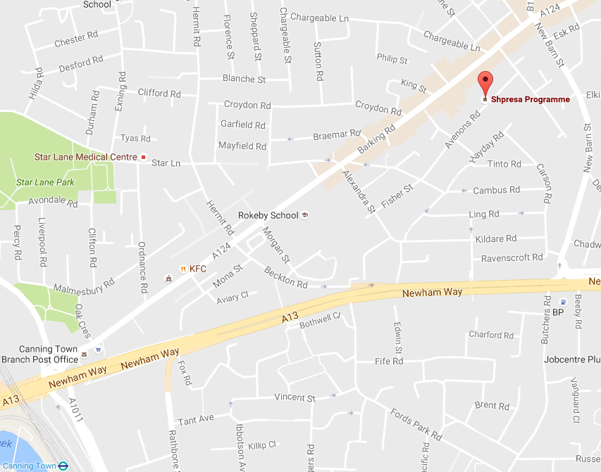

Train: The office is a 10-15 minute walk up Barking Road from **Canning Town Underground and DLR**, or a 5-10 minute journey on the **5, 300 or 330** buses from just outside the station. The buses depart from **Bus Stop F** **(Canning Town Bus Station)** and the nearest stop to the office is **Bus Stop BH (King Street)**.

Bus: The nearest stops are:  
**Bus Stop BH (King Street) for buses East** towards Newham, East Ham and Romford: 5, 115, 276, 300, 330 **(= 3-4 minutes away)**

**Bus Stop BE (Croydon Road) for buses West** towards Canning Town, Aldgate and Stoke Newington: 5, 115, 276, 300, 330 **(= 3-4 minutes away)**

**Bus Stop Newham Way New Barn Street** towards Beckton and Stratford New Town: 241 and 325 **(= 7-8 minutes away)**

**Bus Stop AD (Esk Road)** towards Prince Regent and Canning Town: 241 and 325 **(= 4-5 minutes away)**

**Contact Us:**

Email: info@horizon-lac.co.uk

Website: www.horizon-lac.co.uk

Telephone: 0203 637 6781