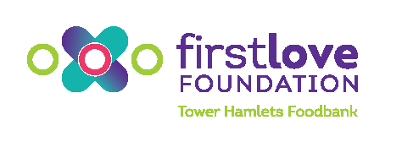
Referral Form
Client Information
Client name: |  |  |  |  |  |  |  | No of adults: |  |  |  | No of children:
Client address:
Referring org: |  |  |  |  |  |  |  | Staff name:
Foodbank session:
Enter the location [first box] and date [second box – DD/MM/YYYY] of the Foodbank session client will attend.
Referral Information
Has the client been referred previously? |  |  |  |  |  |  | Has client applied for Crisis Grant?
Date of last referral  If client has attended previously please enter date that voucher was issued [DD/MM/YYYY] |  |  |  |  |  |  | Crisis grant details  If client has not applied for a CSG please give details of the reason for this. If a CSG has been applied for please detail whether this was successful, and the date.
Nature of crisis: |  |  |  |  |  |  | Details of support received:  Please detail the support your service is providing to the client, and details of any advice/support they have obtained elsewhere.
‘Other’ reason:
Details of crisis:
NB: if in relation to a cut or delay in benefits please be specific about the type of benefit, reasons for delay or suspension, and dates.
Terms & Conditions
By ticking these boxes you confirm that all off the below actions have been taken.
Client has been informed that their information will be shared with First Love Foundation and partner organisations of the Advice & Support Project
Client has been informed that Food Bank vouchers cannot be given or sold to a third party, under any circumstances
Client has been informed that food obtained from the Food Bank cannot be given or sold to a third party, under any circumstances
Client has been informed that they must bring ID and their voucher to the Foodbank, along with any relevant paperwork (i.e. letters relating to benefits / income)
Client has been advised to bring a trolley or case to carry heavy food
Client understands, and is in agreement with the above
E-mail this completed form to distributor@firstlovefoundation.org.uk. Once the referral is assessed you will receive an e-mail with a voucher code and instructions to pass on to your client.
If you have any questions please telephone 020 3069 9877

OFFICE USE ONLY
Referral form reviewed: |  |  |  | Sent to ELPM: |  |  |  |  | Voucher No: |  |  |  | Signed off by:

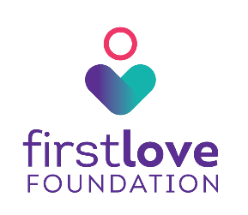
Tower Hamlets Foodbank is coordinated by First Love Foundation
Registered Charity in England and Wales | Charity Number: 1137819
First Love Foundation, C18 Poplar Business Park, 10 Prestons Road, London, E14 9RL
firstlovefoundation.org.uk | twitter.com/firstlovefdn | facebook.com/firstlovefdn

