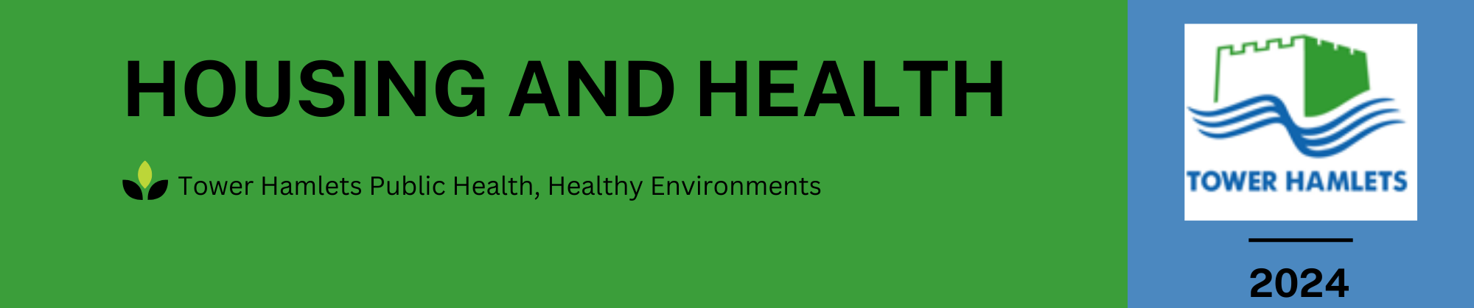

A good home is a vital building block for good health. This resource is for use by health and social care professionals who have patients with housing problems. It is intended to demystify the housing system and support health and social care professionals to steer residents to the right sources of support.

**How the social housing register works**

Social housing is rented from the Council *or* housing associations (e.g Clarion, Poplar HARCA). It is affordable, offers secure tenancies and protected rights. Although there are many different social landlords, all of the homes are rented via the common housing register.

The Common Housing Register is the list of people waiting for Social Housing. There are currently over 24,399 households on the register (January 2024).

When joining the Common Housing Register, residents are allocated a band indicating the priority they have been granted:

Band 1: high priority need - emergencies, priority decants, under-occupiers, priority medical/ social, other priority target groups

Band 2: priority need - overcrowded applicants, homeless applicants, applicants in housing need without a local connection

Band 3: general housing options

**Average waiting time in years, based on actual lets for the financial year 2023/24:**

|  |  |  |  |  |  |
| --- | --- | --- | --- | --- | --- |
| Studio | 1 Bed | 2 Bed | 3 Bed | 4 Beds | 5+ Beds |
| 2 | 3 | 5 | 7 | 7 | 11 |
| 5 | 6 | 7 | 12 | 12 | No lets |
| 10 | 6 | No lets | No lets | No lets | No lets |

**Medical Priority**

* Medical priority is when priority on the housing register is given to residents who have medical condition(s) which are worsened by their housing situation. The applicant, or a member of their household, must have:
  + A severe and long-term limiting illness, or a permanent and substantial disability AND
  + their health or quality of life is severely affected by the home they live in.
* If a resident would like to apply for medical priority they need to contact the council. The resident will be sent a questionnaire to fill in - they should fill this form in themselves.
* **If the council requires a report from the resident’s healthcare professional, the council will request this and pay for it directly. There is no benefit in a letter being obtained from a healthcare professional in advance of one being requested by the Council.**

**How to support a resident with a housing health and safety issue: pathways**

Over the following two pages, we have outlined pathways for use by professionals working with residents who have problems with their homes that could affect their health and safety e.g. damp and mould or disrepair. These pathways are intended to support professionals to correctly signpost residents, enabling them to advocate for themselves where possible.

|  |
| --- |
| 32a4ef98be9d4535be229c94063a75ea.png |

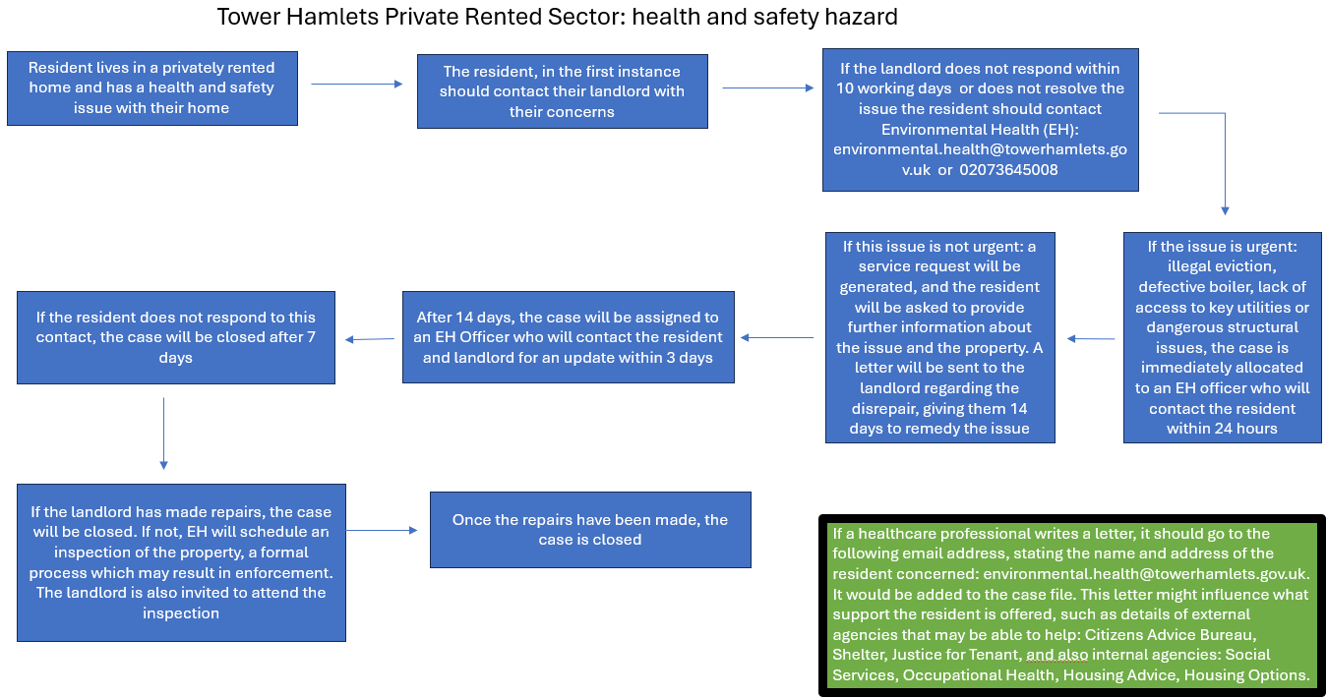

**Environmental Health**

Environmental Health is part of the council and is responsible for ensuring homes are safe. They investigate complaints and deal with problems, making assessments based on the [Housing Health and Safety Rating System](https://www.gov.uk/government/publications/hhsrs-operating-guidance-housing-act-2004-guidance-about-inspections-and-assessment-of-hazards-given-under-section-9) of 29 Hazards, which includes damp and mould.

If a landlord doesn’t deal with a hazard in the home, residents can contact the Environmental Health team for support (see the pathway above).

If a hazard presents a serious and immediate risk to a person's health and safety, this is known as a Category 1 hazard. If a hazard is less serious or less urgent, this is known as a Category 2 hazard.

The council can give landlords:

• unofficial recommendations on the repairs they should do

• legal notices that force landlords to do repairs

Although Environmental Health’s focus is on the Private Rented Sector, residents living in social rented properties can also seek help if their landlord isn’t providing a safe home.

**How to support a resident who is living in an unsuitable home**

* In Tower Hamlets, like other areas of London, there are not enough homes available for social rent. Tower Hamlets is the most densely populated local authority in England.
* It can take years for an appropriate home to become available, while waiting, it is important that residents let the council know if there are any changes in circumstances that could affect their priority banding, such as:
  + A change in household size or composition
  + A new medical issue that may result in medical priority being granted (see medical priority above)

**Signposting**

Below are resources for further support with housing issues

|  |  |
| --- | --- |
| For professionals | [NICE factsheet for professionals on improving indoor air quality](https://www.nice.org.uk/guidance/ng149/resources/visual-summary-pdf-7022755693) |
| For residents | [Shelter: housing charity](https://england.shelter.org.uk/)  [Reporting a rogue landlord to the Greater London Authority](https://www.london.gov.uk/programmes-strategies/housing-and-land/improving-private-rented-sector/report-rogue-landlord-or-agent)  [Tower Hamlets support with the cost of living, including food and fuel poverty and benefits advice](https://www.towerhamlets.gov.uk/lgnl/advice_and_benefits/cost-of-living/Cost-of-living.aspx) |
| Advice on damp and mould | [Citizens advice: Damp and mould guidance](https://www.citizensadvice.org.uk/housing/repairs-and-housing-conditions/repairs-and-housing-conditions/common-problems/repairs-damp/)  [Tower Hamlets Council damp and mould advice](https://www.towerhamlets.gov.uk/lgnl/housing/Health_and_housing/Damp-and-mould/Damp_and_mould.aspx) |

**Acknowledgements**

Thank you to the Tower Hamlets Health and Housing Task and Finish Group for their support in developing this resource:

Katy Scammell, Associate Director of Public Health (Chair), Elizabeth Skillen, Housing Management Policy, Chris Martin, Repairs Contract Manager, Tower Hamlets Homes, Geraldine O’Donnell: Head of Safeguarding and Quality Assurance (or rep), John Harkin: Team Manager Assessment and Attainment, Kerry Greenan: GP+ ICB lead Population Health and Neighbourhoods incl. Homelessness Tower Hamlets, Muna Hassan: rep for THT Board for community voice, Natalie Lovell, Public Health Programme Manager, Natasha Kangwa, Neighbourhood Housing Officer, Rachel Parker, GP + NEL ICB Clinical Lead for Air Quality, Rehana Begum: EH Officer, Health and Housing, Sarah Metcalfe, Public Health Programme Officer, Susie Hannah: Head of Primary Care Transformation, GPCG (or rep), Tori Hadaway: Community Children’s Specialist Asthma Nurse